DATE:

RISK LEVEL
LOW/MEDIUM/HIGH/CRITICAL
THIRD PARTY RISK ASSESSMENT
VENDOR NAME:

Table of Contents

Executive Summary 1
Vendor Profile 2
Vendor Product & Service Information 2
Purpose 2
Risk Assessment Findings 2
Identified Risks 4
Remediation Status 8
Historical Breaches or Incidents Identified in the Past 3 Years 8
Vendor Specific Risk Mitigation Plan 9
Exceptions Noted 11
Recommendation 12
Conclusion 12
Appendix 13
Risk Assessment Approach 13

Executive Summary
A comprehensive risk assessment of company x was completed on Apr 28, 2025. The vendor is aligned with the client's specific business requirements and security standards. It is recommended that company x review the identified risks before approving company x.

Key Findings:
- The assessed controls aligned with company x’s security standards. The overall vendor risk for company x has been evaluated and classified as High.
- We identified ten specific gaps:
  - Four sub-controls have been categorized as High risks.
  - Six sub-controls have been categorized as Moderate risks.

# | Section name | Risk Description | Risk Rating
1. | Document Request | The vendor is not SOC 2 Type 2 attested. | High
2. | Document Request | The vendor does not have a Penetration Test Report. | High
3. | Hosting & Servers | The vendor does not prohibit the use of production data in non-production environments. | High
4. | Authentication | The vendor does not support SCIM on their platform. | High
5. | Remote Access | The vendor does not support IP restriction capabilities. | Moderate
6. | Application & Change Management | Patch Management SLA Misalignment Leading to Extended Exposure to Critical Vulnerabilities. | Moderate
7. | Application & Change Management | The vendor does not have a bug bounty program. | Moderate
8. | Incident Response | The vendor has not disclosed the timeframe of data breach notification. | Moderate
9. | Access Control | The vendor has inadequate access controls across vendor departments. | Moderate
10. | Data Retention & DSR Procedures | The vendor has an inadequate timeframe for retaining customer logs. | Moderate

Essential documentation has been tabulated below:
Description | Status | Provided by Vendor (Yes/No/N/A)
ISO 27001 Certification | N/A | No
SOC 2 Type 2 Attestation | N//A | No

** SOC 2 Type 2 Report and Pentest report will be provided by company x and the report will be updated accordingly.

Vendor Profile

Vendor Product & Service Information
Name of Vendor: | company x
Functionality: Briefly describe the functionality of the products or services provided | company x manages, detects, and responds to prevalent threats across cloud, identity, and endpoint.
Data Categorization: | Vendor 1 may collect and access security-related data such as user identities, authentication logs, endpoint telemetry, cloud service activity, and threat detection information to manage, detect, and respond to threats across cloud, identity, and endpoint environments.
Vendor Categorization: | SaaS

Purpose
This report assesses the effectiveness of the management, operational, and technical security controls implemented for company x. It identifies relevant threats and vulnerabilities, evaluates the likelihood of exploitation, assesses the associated impact, and determines the overall risk level. The report documents the risk assessment activities conducted on Apr 28, 2025. It provides a comprehensive understanding of the potential risks to company x in engaging with company x as a third-party product and service provider.

Risk Assessment Findings
The vendor risk assessment was conducted on Apr 28, 2025.
The following statistics portray the insights gained by the assessment sent to the vendor:
Total number of controls | 182
Identified Risks | 8
Controls that could not be addressed | 65
Number of addressed controls | 122
Completion Percentage | 67.03%

The overall statistics have been graphically presented below:
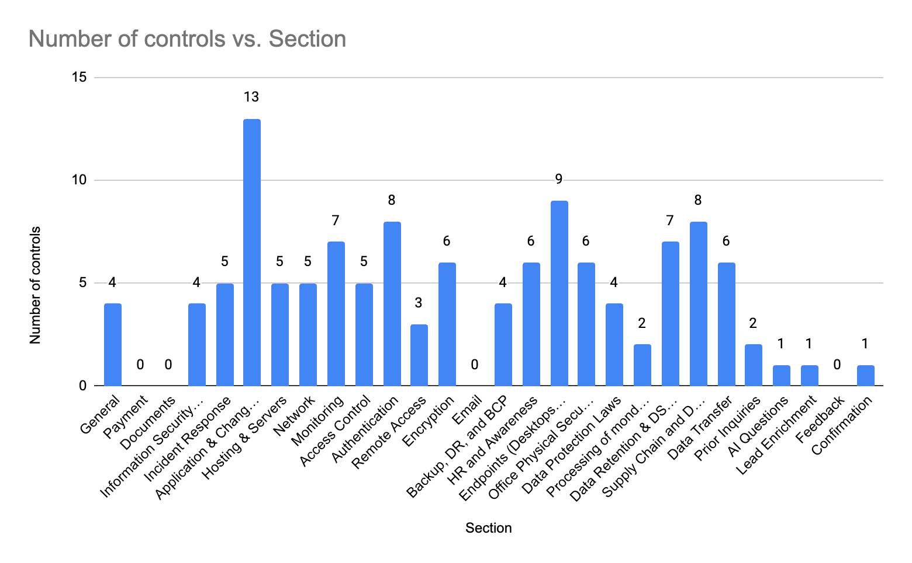

Risk Level | Risk Count
Very Low | 0
Low(1-3) | 0
Moderate (4-9) | 6
High(10-19) | 4
Critical(20-25) | 0

Identified Risks
Risk | #1
Risk Description | The vendor is not SOC 2 Type 2 attested.
Likelihood | High
Impact | High
Risk Level | High
Proposed Remediation | The vendor should obtain SOC 2 Type 2 attestation (or demonstrate an acceptable equivalent) to validate that appropriate security controls are in place.
Vendor’s Comment

Risk | #2
Risk Description | The vendor does not have a Penetration Test Report
Likelihood | High
Impact | High
Risk Level | High
Proposed Remediation | The vendor must obtain and provide a comprehensive, third-party Penetration Test Report to validate their security posture and mitigate potential vulnerabilities.
Vendor’s Comment

Risk | #3
Risk Description | The vendor does not prohibit the use of production data in non-production environments.
Likelihood | High
Impact | High
Risk Level | High
Proposed Remediation | The vendor should enforce strict policies to prohibit production data in non-production environments, ensuring sensitive information is not exposed or improperly accessed.
Vendor’s Comment

Risk | #4
Risk Description | The vendor does not support SCIM on their platform.
Likelihood | High
Impact | High
Risk Level | High
Proposed Remediation | The vendor should implement custom integrations for SCIM authentication, leveraging in-house expertise or third-party solutions to bridge the gap in support.
Vendor’s Comment

Risk | #5
Risk Description | The vendor does not support IP restriction capabilities.
Likelihood | Moderate
Impact | Moderate
Risk Level | Moderate
Proposed Remediation | The vendor should implement or integrate IP whitelisting or other network access control methods so that the client's systems can only be accessed from specified static IP addresses, thus reducing unauthorized access risks.
Vendor’s Comment

Risk | #6
Risk Description | Patch Management SLA Misalignment Leading to Extended Exposure to Critical Vulnerabilities.
Likelihood | Moderate
Impact | Moderate
Risk Level | Moderate
Proposed Remediation | The vendor should implement revised patch management processes to ensure critical vulnerabilities are patched within 3 days, high within 7 days, medium within 90 days, and low within 180 days.
Vendor’s Comment | The patch SLAs are defined as follows:  - Critical patches are addressed within 7 calendar days or as soon as technically feasible.  - High priority patches are handled within 30 calendar days.  - Medium priority patches are resolved within 90 calendar days.  - Low priority patches' timelines vary based on risk assessment, available resources, and other backlog items.  [company name] also continuously monitors for new vulnerabilities using security tools and respond to emerging threats in alignment with industry best practices.

Risk | #7
Risk Description | The vendor does not have a bug bounty program.
Likelihood | Moderate
Impact | Moderate
Risk Level | Moderate
Proposed Remediation | The vendor should implement a formal vulnerability disclosure policy and maintain open channels for responsible reporting, ensuring timely identification and remediation of potential security issues even without a bug bounty program.
Vendor’s Comment

Risk | #8
Risk Description | The vendor has not disclosed the timeframe of data breach notification.
Likelihood | Moderate
Impact | Moderate
Risk Level | Moderate
Proposed Remediation | The vendor should mandate a clearly defined and contractually binding timeframe for data breach notifications, ensuring the vendor provides disclosure to affected parties within 72 hours and complies with all regulatory requirements.
Vendor’s Comment | Our approach is we first determine the exposure of the information and determine the source of the security or privacy issue. We will communicate promptly by using in-product messaging, email, and our status page to affected customers. We will also provide periodic updates as needed to ensure the appropriate resolution of any incident.  Any concerns or incidents can be reported to:  ➔ security@[company name].com  ➔ privacy@[company name].com

Risk | #9
Risk Description | The vendor has inadequate access controls across vendor departments.
Likelihood | Moderate
Impact | High
Risk Level | Moderate
Proposed Remediation | The vendor should implement strict access controls and data segmentation to ensure only the necessary departments (preferably R&D and support) have permission to view and handle the data, minimizing unauthorized access across the vendor organization.
Vendor’s Comment | Providing services with direct involvement in your account: Customer Success, Technical Support, and, if applicable, advanced client services. These are supported by our Engineering, Product, and Data teams for cross-company escalations and product enhancements.

Risk | #10
Risk Description | The vendor has an inadequate timeframe for retaining customer logs.
Likelihood | Moderate
Impact | High
Risk Level | Moderate
Proposed Remediation | Establish and enforce a defined retention schedule for customer logs of at least 180 days, ensuring compliance with regulatory requirements and supporting operational needs for audits and investigations.
Vendor’s Comment | Customer data is retained for the duration of the customer's engagement with [company name]. Once a customer parts ways with [company name], their data is deleted within 90 days. [company name] may retain a customer's data in snapshots in backups which naturally age and are purged as the data lifecycle continues. Customer data is stored on virtual storage devices that are logically separated from other customers.  For more information, please see our privacy policy: https://www.[company name].com/legal/privacy-policy#h-9-personal-data-retention

Remediation Status
Required Document | Status | Vendor Comment | Exception Noted | Remarks | Remediation Timeline
Pentest Report | Not Provided | None | No exceptions noted. | None
SOC 2 Type 2 | Not Provided | None | No exceptions noted. | None
SOC 1 Type 2 | Not Provided | None | No exceptions  noted. | None
Test Questions | Provided | None | Exceptions noted. | A total of 10 risks have been identified that have been outlined in the “Identified Risks” section.

Historical Breaches or Incidents Identified in the Past 3 Years
There have been no records of recent data breaches.

Vendor Specific Risk Mitigation Plan
This section outlines the identified security gaps in the vendor’s current controls and specifies the required actions and timelines for resolution. This plan serves as a pre-condition for onboarding, ensuring that the vendor meets company x’s security and compliance standards before approval.

Risk # | Risk Description | Risk Level | Required Action from Vendor | Timeline for Resolution
1 | The vendor is not SOC 2 Type 2 attested. | High | Obtain SOC 2 Type 2 attestation or provide equivalent security evidence (e.g., ISO 27001, third-party audits). | TBD
2 | The vendor does not have a Penetration Test Report. | High | Conduct a third-party penetration test, address identified vulnerabilities, and provide test results with remediation updates. | TBD
3 | The vendor does not prohibit the use of production data in non-production environments. | High | Implement data masking, enforce policies restricting production data use, apply access controls, and conduct regular audits. | TBD
4 | The vendor does not support SCIM on their platform. | High | Provide an alternative method for automated user provisioning and deprovisioning or define a roadmap for SCIM support. | TBD
5 | The vendor does not support IP restriction capabilities. | Moderate | Implement IP allowlisting or provide alternative security controls for access restrictions. | TBD
6 | Patch Management SLA Misalignment Leading to Extended Exposure to Critical Vulnerabilities. | Moderate | Align patching SLAs with industry standards, ensure timely remediation of critical vulnerabilities, and provide a patching policy. | TBD
7 | The vendor does not have a bug bounty program. | Moderate | Establish a responsible disclosure program or implement alternative security testing measures. | TBD
8 | The vendor has not disclosed the timeframe of data breach notification. | Moderate | Define and commit to a clear data breach notification timeline aligned with regulatory requirements. | TBD
9 | The vendor has inadequate access controls across vendor departments. | Moderate | Enforce role-based access controls (RBAC), implement least privilege principles, and regularly review access rights. | TBD
10 | The vendor has an inadequate timeframe for retaining customer logs. | Moderate | Align log retention policies with compliance standards and customer requirements, ensuring sufficient storage duration. | TBD

Exceptions Noted
The following exceptions were noted after the evaluation of the vendor’s responses to the questionnaire:
- The vendor has a comprehensive Change Management process. However, it is unclear how the approval process takes place.

Additionally, the vendor did not submit the following documents:
- Pentest Report
- SOC 2 Type 2 Report
- ISO Certifications

Recommendation
After conducting a comprehensive review of company x on Apr 28, 2025, it is evident that the vendor is aligned with the specific business requirements and goals of company x. The vendor has demonstrated cooperation by providing the required assessment documents and additional resources regarding its IT policies and practices.
After a thorough risk assessment, it is recommended that company x review the identified risks before approving Company X.

Conclusion
In conclusion, majority controls are aligned with company x’s Third Party Security Standards within the Third-Party Management Policy. As a result of the assessment, we identified a total of ten specific gaps, with four risks classified as high risks and six risks classified as moderate risks. The vendor risk assigned to company x is classified as High, considering the nature of the products and services. By adhering to the assessment findings and recommendations, company x can strengthen its vendor risk management practices and ensure the security of its systems and data.

Appendix

Risk Assessment Approach
This risk assessment is conducted following the NIST SP 800-30, Guide for Conducting Risk Assessments. Risks were evaluated by considering threat events, their likelihood of occurrence, system vulnerabilities, mitigating factors, and the potential consequences/impact on the mission.

We utilized the following documents provided by the vendor as a part of the assessment:
- Test Questionnaire

We also collected the necessary information by reviewing vendor websites, and security documentation and contacting the vendor's InfoSec & GRC teams for support as needed.

This risk assessment follows the guidelines provided in NIST SP 800-30, Guide for Conducting Risk Assessments. Risk will be evaluated by considering threat events, their likelihood of occurrence, system vulnerabilities, mitigating factors, and the potential consequences/impact on the mission.

The following tables from the NIST SP 800-30 were used to assign values to likelihood, impact, and risk:

Table 2: Assessment Scale – Likelihood of Threat Event Initiation (Adversarial)
Qualitative Values | Description
Very High | The adversary is almost certain to initiate the threat event.
High | The adversary is highly likely to initiate the threat event.
Moderate | The adversary is somewhat likely to initiate the threat event.
Low | The adversary is unlikely to initiate the threat event.
Very Low | The adversary is highly unlikely to initiate the threat event

Table 3: Assessment Scale – Likelihood of Threat Event Occurrence (Non-adversarial)
Qualitative Values | Description
Very High | Error, accident, or act of nature is almost certain to occur; or occurs more than 100 times per year.
High | Error, accident, or act of nature is highly likely to occur; or occurs between 10-100 times per year.
Moderate | Error, accident, or act of nature is somewhat likely to occur; or occurs between 1-10 times per year.
Low | Error, accident, or act of nature is unlikely to occur; or occurs less than once a year, but more than once every 10 years.
Very Low | Error, accident, or act of nature is highly unlikely to occur; or occurs less than once every 10 years.

Table 4: Assessment Scale – Impact of Threat Events
Qualitative Values | Description
Very High | The threat event could be expected to have multiple severe or catastrophic adverse effects on organizational operations, organizational assets, individuals, other organizations, or the Nation.
High | The threat event could be expected to have a severe or catastrophic adverse effect on organizational operations, organizational assets, individuals, other organizations, or the Nation. A severe or catastrophic adverse effect means that, for example, the threat event might: (i) cause severe degradation in or loss of mission capability to an extent and duration that the organization is not able to perform one or more of its primary functions; (ii) result in major damage to organizational assets; (iii) result in major financial loss; or (iv) result in severe or catastrophic harm to individuals involving loss of life or serious life-threatening injuries.
Moderate | The threat event could be expected to have a serious adverse effect on organizational operations, organizational assets, individuals, other organizations, or the Nation. A serious adverse effect means that, for example, the threat event might: (i) cause significant degradation in mission capability to an extent and duration that the organization is able to perform its primary functions, but the effectiveness of the functions is significantly reduced; (ii) result in significant damage to organizational assets; (iii) result in significant financial loss; or (iv) result in significant harm to individuals that do not involve loss of life or serious life-threatening injuries.
Low | The threat event could be expected to have a limited adverse effect on organizational operations, organizational assets, individuals, other organizations, or the Nation. A limited adverse effect means that, for example, the threat event might: (i) cause a degradation in mission capability to an extent and duration that the organization is able to perform its primary functions, but the effectiveness of the functions is noticeably reduced; (ii) result in minor damage to organizational assets; (iii) result in minor financial loss; or (iv) result in minor harm to individuals.
Very Low | The threat event could be expected to have a negligible adverse effect on organizational operations, organizational assets, individuals, other organizations, or the Nation.

Table 5: Assessment Scale – Level of Risk (Combination of Likelihood and Impact)
Likelihood (That Occurrence Results in Adverse Impact) | Level of Impact
 | Very Low | Low | Moderate | High | Very High
Very High | Very Low | Low | Moderate | High | Very High
High | Very Low | Low | Moderate | High | Very High
Moderate | Very Low | Low | Moderate | Moderate | High
Low | Very Low | Low | Low | Low | Moderate
Very Low | Very Low | Very Low | Very Low | Low | Low

Table 6: Assessment Scale – Level of Risk
Qualitative Values | Description
Very High | Threat events could be expected to have multiple severe or catastrophic adverse effects on organizational operations, organizational assets, individuals, other organizations, or the Nation.
High | Threat events could be expected to have a severe or catastrophic adverse effect on organizational operations, organizational assets, individuals, other organizations, or the Nation.
Moderate | Threat events could be expected to have a serious adverse effect on organizational operations, organizational assets, individuals, other organizations, or the Nation.
Low | Threat events could be expected to have a limited adverse effect on organizational operations, organizational assets, individuals, other organizations, or the Nation.
Very Low | Threat events could be expected to have a negligible adverse effect on organizational operations, organizational assets, individuals, other organizations, or the Nation.

